**МИНИСТЕРСТВО ОБРАЗОВАНИЯ РЕСПУБЛИКИ БЕЛАРУСЬ**

**УЧРЕЖДЕНИЕ ОБРАЗОВАНИЯ**

**ГОМЕЛЬСКИЙ ГОСУДАРСТВЕННЫЙ ТЕХНИЧЕСКИЙ УНИВЕРСИТЕТ ИМЕНИ П. О. СУХОГО**

Факультет автоматизированных и информационных систем

Кафедра «Информационные технологии»

ОТЧЕТ ПО ЛАБОРАТОРНОЙ РАБОТЕ № 8

по дисциплине «Программирование сетевых приложений»

на тему:

**«Разработка HTTP­сервисов»**

Выполнил: студент гр. ИТИ-41

Федоренко А.В.

Принял: преподаватель

Карабчикова Е.А.

Гомель 2020

**Цель работы:** научиться разрабатывать приложения с использованием web-сокетов.

**Задание**: Разработать HTTP­сервис по выбранной теме ­ реализовать CRUD (Create-Read-Update-Delete) операции.

Обязательно оолжны использоваться запросы в стиле REST:

– GET для получения данных;

– POST для создания ресурса (сохранения данных);

– PUT для обновления ресурса (обновление данных);

– DELETE для удаления ресурса (удаления строк).

На сервере использовать любую БД для хранения данных. Клиентское приложение: это html­страница, где запросы (вызовы сервиса) осуществляются с использованием AJAX.

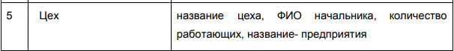

Рисунок 1 – Вариант задания

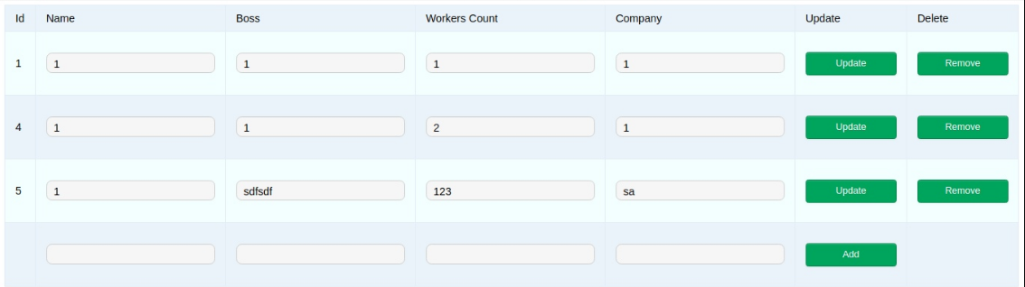

Рисунок 2 – html-страница

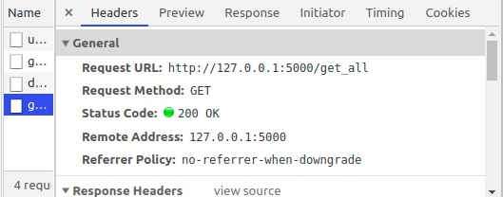

Рисунок 3 – GET-запрос

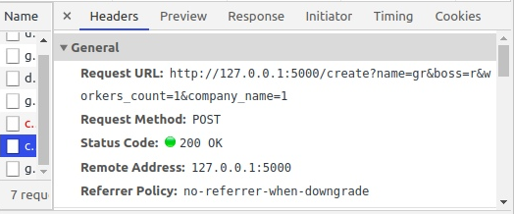

Рисунок 4 – POST-запрос

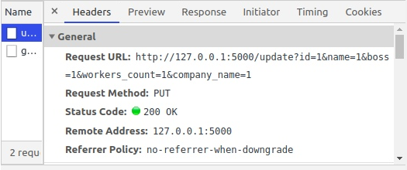

Рисунок 5 – PUT-запрос

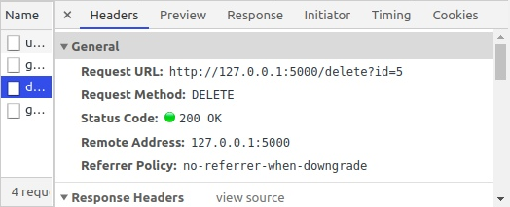

Рисунок 5 – DELETE-запрос

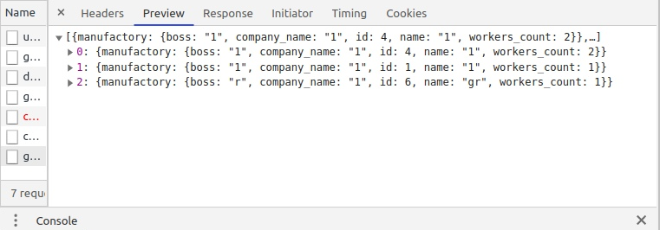

Рисунок 6 – Ответ в JSON-формате

**Вывод:** в ходе выполнения лабораторной работы был разработан http­сервис с реализацией CRUD.

**Приложение А**

**Листинг программы**

Класс Manufacture:

from app.db import db

class Manufactory(db.Model):

__tablename__ = 'manufactory'

id=db.Column('id', db.Integer, primary_key=True)

name=db.Column('name', db.String(32))

boss=db.Column('boss', db.String(32))

workers_count=db.Column('workers_count', db.Integer)

company_name=db.Column('company_name', db.String(32))

@property

def serialize(self):

return {'manufactory': {'id': self.id, 'name': self.name, 'boss': self.boss, 'workers_count': self.workers_count,

'company_name': self.company_name}}

@property

def serialize_many2many(self):

return [item.serialize for item in self.many2many]

create:

from flask import request, jsonify

from app import app, app_logger

from app.db import db

from app.models.manufactory import Manufactory

logger = app_logger.get_logger(__name__)

@app.route('/create', methods=["POST"])

def create():

response = None

try:

logger.info('Handling request: Adding a record to a table')

manufactory_name = request.args.get('name')

manufactory_boss = request.args.get('boss')

manufactory_workers_count = request.args.get('workers_count')

manufactory_company_name = request.args.get('company_name')

manufactory = Manufactory(name=manufactory_name, boss=manufactory_boss,

workers_count=manufactory_workers_count,

company_name=manufactory_company_name)

db.session.add(manufactory)

db.session.commit()

response = jsonify({'success': 'Record added successfully.'})

response.status_code = 200

except Exception as e:

db.session.rollback()

response = jsonify({'error': 'The request had invalid values.'})

response.status_code = 400

logger.error(str(e))

finally:

return response

delete:

from flask import request, jsonify

from app import app, app_logger

from app.db import db

from app.models.manufactory import Manufactory

logger = app_logger.get_logger(__name__)

@app.route('/delete', methods=["DELETE"])

def delete():

response = None

try:

logger.info('Handling request: Delete record by id')

mid = request.args.get('id')

db.session.query(Manufactory).filter_by(id=mid).delete()

db.session.commit()

response = jsonify({'success': 'Record successfully deleted.'})

response.status_code = 200

except Exception as e:

db.session.rollback()

response = jsonify({'error': 'The request had invalid values.'})

response.status_code = 400

logger.error(str(e))

finally:

return response

get_all:

from flask import jsonify

from app import app, app_logger

from app.db import db

from app.models.manufactory import Manufactory

logger = app_logger.get_logger(__name__)

@app.route('/get_all', methods=["GET"])

def get_all():

try:

logger.info('Handling request: Getting a list of records')

query_list = db.session.query(Manufactory)

response = jsonify([i.serialize for i in query_list.all()])

return response

except Exception as e:

logger.error(str(e))

update:

from flask import request, jsonify

from app import app, app_logger

from app.db import db

from app.models.manufactory import Manufactory

logger = app_logger.get_logger(__name__)

@app.route('/update', methods=["PUT"])

def update():

response = None

try:

logger.info('Handling request: Updating a record in a table')

manufactory_id = request.args.get('id')

manufactory_name = request.args.get('name')

manufactory_boss = request.args.get('boss')

manufactory_workers_count = request.args.get('workers_count')

manufactory_company_name = request.args.get('company_name')

manufactory = db.session.query(Manufactory).get(manufactory_id)

manufactory.name = manufactory_name

manufactory.boss = manufactory_boss

manufactory.workers_count = manufactory_workers_count

manufactory.company_name = manufactory_company_name

db.session.commit()

response = jsonify({'success': 'Record successfully updated.'})

response.status_code = 200

except Exception as e:

db.session.rollback()

response = jsonify({'error': 'The request had invalid values.'})

response.status_code = 400

logger.error(str(e))

finally:

return response

index.js:

document.addEventListener('DOMContentLoaded', () => {

get_all();

});

function get_all(){

// Инициализировать новый запрос

var request = new XMLHttpRequest();

request.open('GET', '/get_all');

// Функция обратного вызова, когда запрос завершен

request.onload = () => {

// Извлечение данных JSON из запроса

const data = JSON.parse(request.responseText);

fillTable(data);

}

// Послать запрос

request.send(null);

}

function fillTable(data){

var table = document.getElementById("table");

var text = "<tr><td>Id</td><td>Name</td><td>Boss</td><td>Workers Count</td><td>Company</td><td>Update</td><td>Delete</td></tr>";

for(let i = 0; i < data.length; i++){

let id = data[i].manufactory.id;

let name = data[i].manufactory.name;

let boss = data[i].manufactory.boss;

let workers_count = data[i].manufactory.workers_count;

let company_name = data[i].manufactory.company_name;

text += "<tr>" +

`<td>${id}</td>` +

"<td>" +

`<input type=\"text\" class=\"\input_text\" id=\"name${id}_input\" value=\"${name}\">` +

"</td>" +

"<td>" +

`<input type=\"text\" class=\"\input_text\" id=\"boss${id}_input\" value=\"${boss}\">` +

"</td>" +

"<td>" +

`<input type=\"text\" class=\"\input_text\" id=\"workers_count${id}_input\" value=\"${workers_count}\">` +

"</td>" +

"<td>" +

`<input type=\"text\" class=\"\input_text\" id=\"company_name${id}_input\" value=\"${company_name}\">` +

"</td>" +

"<td>" +

`<a class="green" onclick=\"update_manufactory(${id})\">Update</a>` +

"</td><td>" +

`<a class="green" onclick=\"remove_manufactory(${id})\">Remove</a>` +

"</td></tr>";

}

text += "<tr><td></td><td><input type=\"text\" class=\"\input_text\" id=\"name_input\">" +

"</td><td><input type=\"text\" class=\"\input_text\" id=\"boss_input\">" +

"</td><td><input type=\"text\" class=\"\input_text\" id=\"workers_count_input\">" +

"</td><td><input type=\"text\" class=\"\input_text\" id=\"company_name_input\">" +

"</td><td><a class=\"green\" onclick=\"create_manufactory()\">Add</a>" +

"</td><td></td></tr>"

table.innerHTML = text;

}

function remove_manufactory(id){

var request = new XMLHttpRequest();

request.open("DELETE", '/delete?id=' + id);

// Функция обратного вызова, когда запрос завершен

request.onload = () => {

response = JSON.parse(request.responseText);

if(request.status == '200'){

get_all();

WriteMessage(response.success, true);

}

else{

WriteMessage(response.error, false);

}

}

request.send();

}

function create_manufactory(){

var request = new XMLHttpRequest();

var name = document.getElementById("name_input").value;

var boss = document.getElementById("boss_input").value;

var workers_count = document.getElementById("workers_count_input").value;

var company_name = document.getElementById("company_name_input").value;

request.open("POST", `/create?name=${name}&boss=${boss}&workers_count=${workers_count}&company_name=${company_name}`);

// Функция обратного вызова, когда запрос завершен

request.onload = () => {

response = JSON.parse(request.responseText);

if(request.status == '200'){

get_all();

WriteMessage(response.success, true);

}

else{

WriteMessage(response.error, false);

}

}

request.send();

}

function update_manufactory(id){

var request = new XMLHttpRequest();

var name = document.getElementById(`name${id}_input`).value;

var boss = document.getElementById(`boss${id}_input`).value;

var workers_count = document.getElementById(`workers_count${id}_input`).value;

var company_name = document.getElementById(`company_name${id}_input`).value;

request.open("PUT", `/update?id=${id}&name=${name}&boss=${boss}&workers_count=${workers_count}&company_name=${company_name}`);

// Функция обратного вызова, когда запрос завершен

request.onload = () => {

response = JSON.parse(request.responseText);

if(request.status == '200'){

get_all();

WriteMessage(response.success, true);

}

else{

WriteMessage(response.error, false);

}

}

request.send();

}

function WriteMessage(message, success){

var now = new Date();

status_text = document.getElementById("answertext");

status_text.style.color = success ? "green" : "red";

Year = now.getFullYear();

Month = now.getMonth();

Day = now.getDate();

Hour = now.getHours();

Minutes = now.getMinutes();

Seconds = now.getSeconds();

status_text.innerHTML = `${Year}.${Month}.${Day} ${Hour}:${Minutes}:${Seconds} - ${message}`;

}